ABHISHEK KASHYAP (Week 1)

**Question 1:**

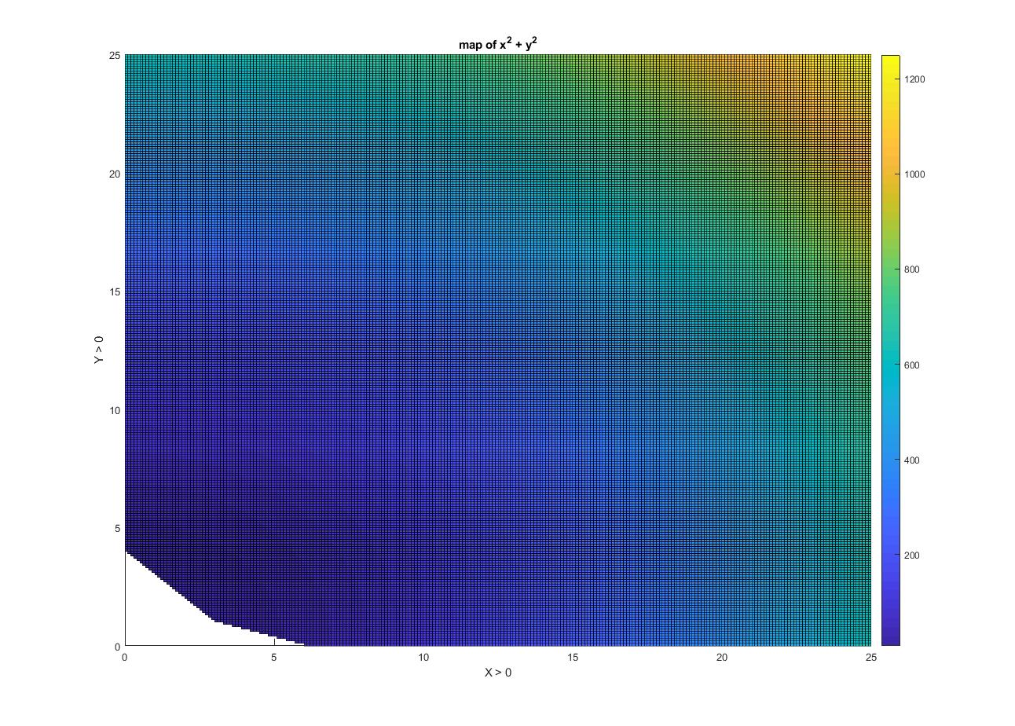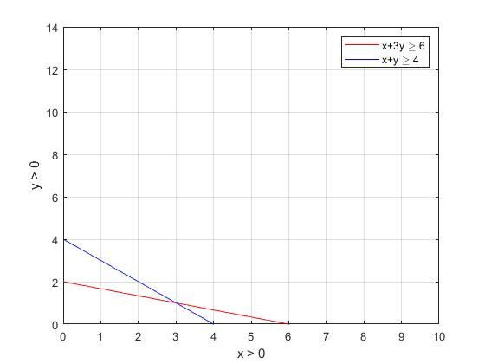Shown below are the inequalities, with the region of interest for both plots more clearly illustrated in the lower figure with a colormap. MATLAB was used to plot the figures. The colormap can be

interpreted as a heat map created using the objective function .

MATLAB codes:

v = -10:0.1:25;

[X,Y] = meshgrid(v);

conditions = (X + 3*Y >= 6) & (X + Y >= 4) ...

& (X >= 0) & (Y >= 0); % contains logical 0's and 1's

conditions = double(conditions);

conditions(conditions == 0) = NaN;

X = X .* conditions;

Y = Y .* conditions;

objective_function = X.^2 + Y.^2;

[app.min_val, Idx] = min(objective_function(:));

[app.min_row, app.min_col] = ind2sub(size(objective_function), Idx);

app.min_val_x = X(app.min_row, app.min_col);

app.min_val_y = Y(app.min_row, app.min_col);

figure, surf(X, Y, objective_function), colorbar, view(0,90)

xlabel('X > 0'), ylabel('Y > 0'), zlabel('X^2 + Y^2'), title('map of x^2 + y^2')

The values that satisfy the optimization are

**Question 2:**

Using basic calculus, let

Taking its derivative and equating it to zero:

For determining maxima, double derivate should be negative:

Plugging in and for in , the optimal objective value is and the optimal solution is .